- What is non-functional testing
- What is performance testing & types
  - Load testing
  - Stress testing
  - Soak/Endurance testing
- Key metrics/KPIs to capture in performance testing
  - Connection time: The time taken by client to establish a valid connection with the server, before sending any request
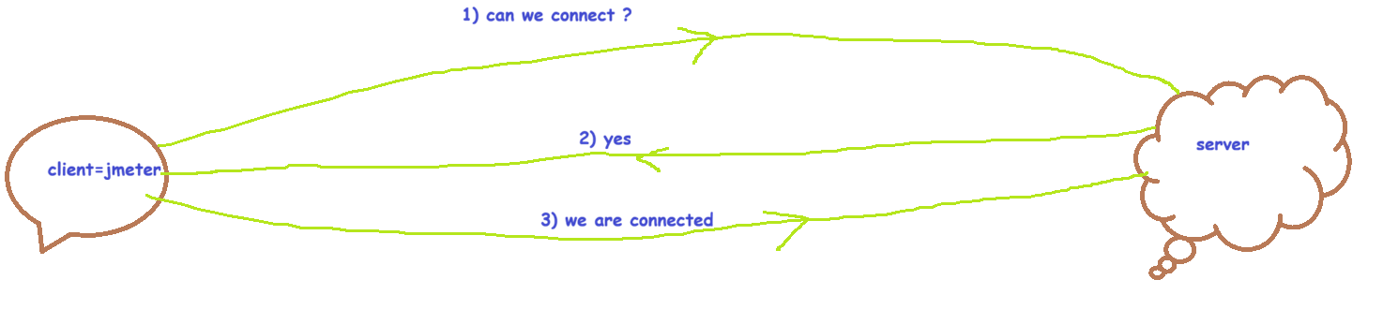
  - Latency: The time taken by server to send the 1st character/packet/byte to the client is called Latency
  - Average response time: The time taken by server to send the entire response to the client is called as Average response time
  - P90 response time: The time taken by server to send the entire response to the top 90% of the clients is called as P90 response time
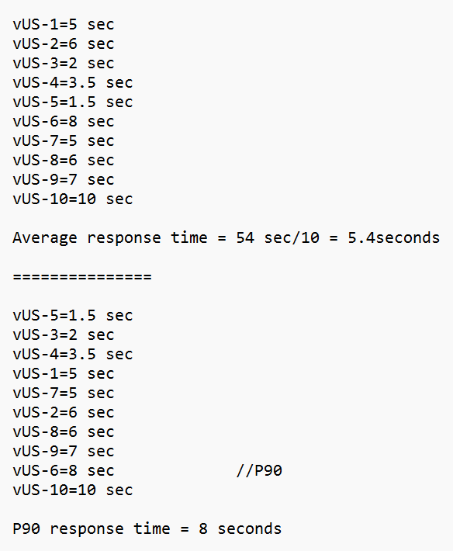
  - P95 response time:
  - P99 response time:
  - Client throughput: # of requests sent from client to server/second
  - Server throughput: # of responses received from server to client/second
  - Size sent: the size of requests sent by client to the server
  - Size received: the size of responses sent by server to the client
- Client & Server architecture
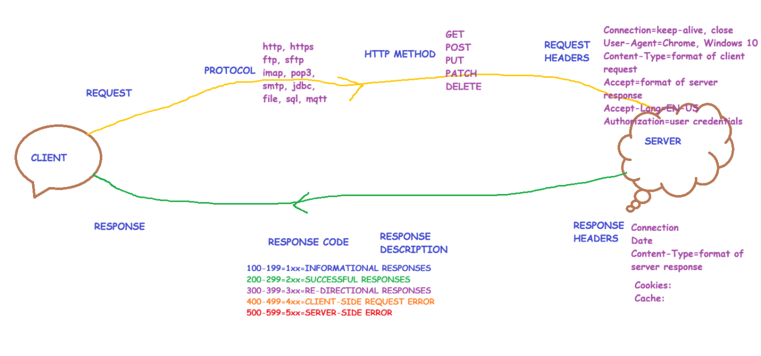
- Why JMeter
- Download/Installation process of JMeter
- JMeter Test Plan elements explained
  - Thread Group: vUsers, iterations, ramp-up etc
  - Samplers: it is the request to be sent
  - Listeners: is the response to be captured
  - Config elements
  - Assertions
  - Logic controllers
  - Timers
  - Pre-Processors
  - Post-Processors
  - HTTPs Test script recorder

PROBLEM STATEMENTS
- Conduct a simple performance test (for vUser=1) on the given web application by navigating multiple web pages
  - https://mindmajix.com/
  - https://mindmajix.com/corporate-training
  - https://mindmajix.com/blog
- Conduct a simple load test (for vUsers=10) on the given web application by navigating multiple web pages
  - https://mindmajix.com/
  - https://mindmajix.com/corporate-training
  - https://mindmajix.com/blog
- Conduct a simple stress test (for vUsers=15, loop count=5) on the given web application by navigating multiple web pages
  - https://mindmajix.com/
  - https://mindmajix.com/corporate-training
  - https://mindmajix.com/blog
- Conduct a simple soak/endurance test (for vUsers=20, duration=30 seconds) on the given web application by navigating multiple web pages
  - https://mindmajix.com/
  - https://mindmajix.com/corporate-training
  - https://mindmajix.com/blog
- Conduct a load/stress/endurance test and save the test results in a .csv file
  - 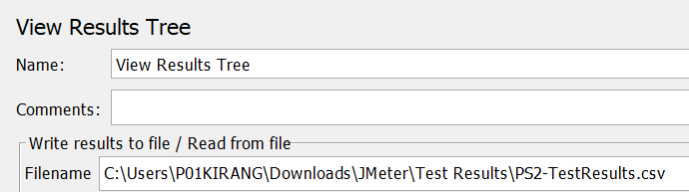
  - 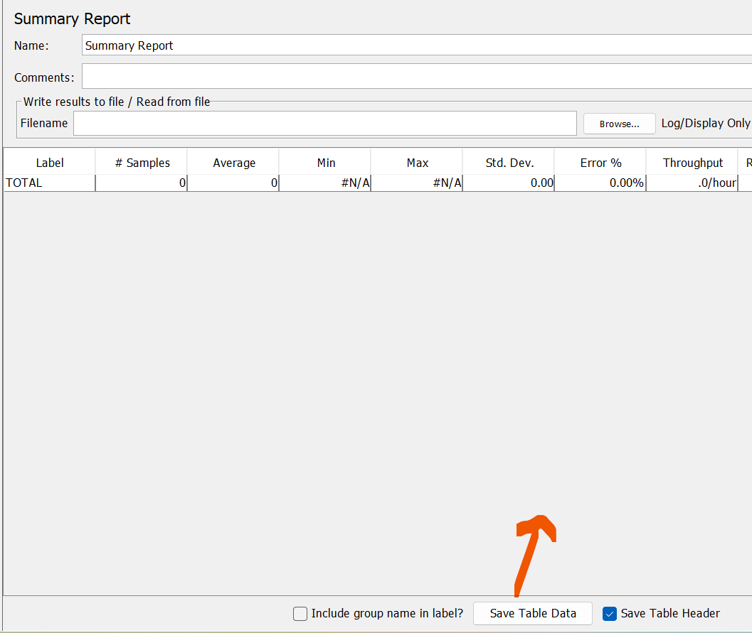
- Conduct a load/stress/endurance test and generate HTML test report
  - Generate test results.csv using View Results Tree or View Results in Table listener
  - Click on Tools menu > Click on ‘Generate HTML report’ > Fill all the 3 fields with the required details > Click on ‘Generate report’ > Navigate to the html folder now > Open index.html on any browser to see the HTML test results
- Conduct a load/stress test on any website application to simulate real browser behavior such as Chrome/Firefox/Safari/Edge
  - https://www.bookswagon.com/
  - https://www.bookswagon.com/promo-best-seller/award-winning/2109CDC4B4DC
  - https://www.bookswagon.com/promo/Medical-Exam/4D875050CCFF
  - https://www.bookswagon.com/featured-authors
  - https://www.bookswagon.com/dealoftheday/TodaysDeal/B88F238E7C9E
  - Click on Config element > Click on HTTP header manager
  - User Agents can be found at https://www.whatismybrowser.com/guides/the-latest-user-agent/
- Conduct a load/stress test on any website application to simulate real browser behavior such as Chrome/Firefox/Safari/Edge along with capabilities to accept incoming server cookies
  - https://www.bookswagon.com/
  - https://www.bookswagon.com/promo-best-seller/award-winning/2109CDC4B4DC
  - https://www.bookswagon.com/promo/Medical-Exam/4D875050CCFF
  - https://www.bookswagon.com/featured-authors
  - https://www.bookswagon.com/dealoftheday/TodaysDeal/B88F238E7C9E
- Conduct a load/stress test on any website application to simulate real browser behavior such as Chrome/Firefox/Safari/Edge along with capabilities to accept incoming server cookies & server cache
  - https://www.bookswagon.com/
  - https://www.bookswagon.com/promo-best-seller/award-winning/2109CDC4B4DC
  - https://www.bookswagon.com/promo/Medical-Exam/4D875050CCFF
  - https://www.bookswagon.com/featured-authors
  - https://www.bookswagon.com/dealoftheday/TodaysDeal/B88F238E7C9E
- Conduct a load/stress test on any website application to simulate various real browsers such as Chrome/Firefox/Safari/Edge using data driven automation testing (volume testing)
  - https://www.bookswagon.com/
  - https://www.bookswagon.com/promo-best-seller/award-winning/2109CDC4B4DC
  - https://www.bookswagon.com/promo/Medical-Exam/4D875050CCFF
  - https://www.bookswagon.com/featured-authors
  - https://www.bookswagon.com/dealoftheday/TodaysDeal/B88F238E7C9E
  - Click on Config element > Click on HTTP header manager
  - Click on Config element > Click on CSV Dataset config
  - User Agents can be found at https://www.whatismybrowser.com/guides/the-latest-user-agent/
  - Syntax of a variable: ${variableName}
- Conduct a load/stress test on any website application to declare the protocol & server name only once
  - Click on Config element > Click on HTTP Request Defaults
- Conduct a load/stress test on any website application to simulate real user behavior with fixed delay between sampler’s execution
  - Use Timers
  - Timers are executed first and then samplers are executed i.e., Timers > Samplers
  - Add Constant Timer to introduce fixed delay during sampler’s execution
- Conduct a load/stress test on any website application to simulate real user behavior with random delay between sampler’s execution
  - Use Timers
  - Timers are executed first and then samplers are executed i.e., Timers > Samplers
  - Add Uniform Random Timer to introduce fixed delay during sampler’s execution
- Conduct a load/stress test on any website application to simulate real user behavior with random delay between sampler’s execution
  - Use Timers
  - Timers are executed first and then samplers are executed i.e., Timers > Samplers
  - Add Gaussian Random Timer to introduce fixed delay during sampler’s execution
- Conduct a load/stress test on any website application to simulate real user behavior with random delay between sampler’s execution
  - Use Timers
  - Timers are executed first and then samplers are executed i.e., Timers > Samplers
  - Add Poisson Random Timer to introduce fixed delay during sampler’s execution
- Conduct a load/stress test on any website application to assert the response such as response code, response message
  - Use Assertions > Response assertion
  - Assertions are functional validations on the response received from server
- Conduct a load/stress test on any website application to assert the response to validate if the response body is non-empty & valid response
  - Use Assertions > Size assertion
  - Assertions are functional validations on the response received from server
- Conduct a load/stress test on any website application to assert the duration of the response
  - Use Assertions > Duration assertion
  - Assertions are functional validations on the response received from server
- Conduct a load/stress test on any website application to implement logic controller-once only controller
- Conduct a load/stress test on any website application to implement logic controller-loop controller
- Conduct a load/stress test on any website application to implement logic controller-random order controller
- Conduct a load/stress test on any website application to implement logic controller-random controller
- Conduct a load/stress test on any website application to implement logic controller- runtime controller
- Conduct a load/stress test on any website application to implement logic controller- throughput controller
- Conduct a load/stress test on any website application to implement logic controller- transaction controller
  - It will implement concurrency among vUsers by running them at the same time i.e., parallel test execution of vUsers
  - It will execute each sampler/request in the sequential order
  - It will provide average response time for each sampler as well as for all samplers executed together
- Conduct a load/stress test on any website application to implement logic controller- critical section controller
  - It will implement non-concurrency among vUsers by running them not at the same time i.e., sequential test execution of vUsers
  - It will execute each sampler/request in the sequential order
  - It will provide average response time for each sampler but not for all the samplers executed together
- Conduct a load/stress test on any website application to implement 2 logic controllers- critical section controller & throughput controller
- Conduct a load/stress test on any website application to implement 2 logic controllers- transaction controller & random controller
- Conduct a load/stress test on any website application to implement logic controller- if controller
- Conduct a load/stress test on any website application to include preProcessors-User Parameters
  - preProcessors are executed first before the samplers i.e., preProcessors > sampler
  - User Parameters are used to define variables
- Conduct a load/stress test on any website application to include preProcessors-Sample Timeout
  - preProcessors are executed first before the samplers i.e., preProcessors > sampler
  - Sample Timeout will wait for the server response until the timeout is not met. Once the timeout is met & the server response is not yet received, the sampler will be failed.
- Conduct a load/stress test on any website application to include preProcessors-HTML Link Parser
  - preProcessors are executed first before the samplers i.e., preProcessors > sampler
  - Wildcard characters:
    - . = match atleast a single character
    - * = match multiple characters
  - HTML Link Parser will parse/scan all the links from the previous sampler response and supply it in the parent sampler where .* is written in the path
- Conduct a load/stress test on any website application to use variables
  - Config element > User defined variables
=========
- Recording in JMeter using Blazemeter chrome plugin
    - https://chromewebstore.google.com/detail/blazemeter-the-continuous/mbopgmdnpcbohhpnfglgohlbhfongabi
    - Install the above chrome plugin
    - Login to Blazemeter
- Web application automation
  - https://katalon-demo-cura.herokuapp.com/profile.php#login
    - Login
    - Book an appointment
    - Logout
- Parameterize the web application automation using DDT-CSV
  - Use the above application to parameterize the test data by supplying it in .CSV file
- Parameterize the web application automation using DDT-JMeter functions
  - Use the above application to parameterize the test data by using JMeter functions
  - Generate test results.csv file
  - Generate .html test report
- Recording in JMeter using JMeter recording feature - HTTP(S) Test Script Recorder
  - http://demo.testfire.net/login.jsp
    - UN: jsmith
    - PWD: demo1234
  - Login > Transfer Funds > Logout
- Parameterize the above web application automation using DDT-CSV
  - Use the above application to parameterize the test data by supplying it in .CSV file
- Parameterize the above web application automation using DDT-JMeter functions
  - Use the above application to parameterize the test data by using JMeter functions
- JMeter CLI mode of test execution
  - JMeter tests can be executed in GUI mode and Non-GUI/CLI mode
  - JMeter tests are faster & efficient when executed in CLI mode as they consume less memory and system resources
  - For heavy load/stress tests, JMeter CLI mode is recommended to be used
  - To run the JMeter .jmx test and to generate .csv test report, use the below command:
    - jmeter -n -t “path of .jmx file” -l “path of .csv test report file to be generated”
  - To run the JMeter .jmx test and to generate .csv & .html test reports, use the command below:
    - jmeter -n -t “path of .jmx file” -l “path of .csv test report file to be generated” -e -o “path of empty output folder”
- Usage of Multiple threads creation in JMeter test plan
  - In JMeter test plan, we can create multiple thread groups
  - However, JMeter doesn’t run the thread groups in sequence. To fix this, click on Test Plan > select the checkbox ‘Run thread groups consecutively’
- Usage of setUp Thread Group
  - setUp thread group gets the 1st precedence/priority as compared to Thread Group
  - Order of test execution:
    - setUp Thread Group > Thread Group
- Usage of tearDown Thread Group
  - tearDown thread group gets the last precedence/priority as compared to Thread Group
  - Order of test execution:
    - Thread Group > tearDown Thread Group
- Usage of setUp thread group, Thread Group & tearDown thread group
  - setUp Thread Group > Thread Group > tearDown Thread Group
- Usage of SMTP sampler
  - SMTP = Simple email transfer protocol
  - This protocol is used to send emails
- REST APIs automation
  - Swagger API documentation:
    - https://demo.testfire.net/swagger/index.html
  - Add required assertions
- REST APIs automation along with DDT-CSV
  - Swagger API documentation:
    - https://demo.testfire.net/swagger/index.html
- REST APIs automation along with DDT-JMeter functions
  - Swagger API documentation:
    - https://demo.testfire.net/swagger/index.html
- Correlation & postProcessors for APIs
  - Correlation is the process where the response of an API is extracted & supplied as request to another dependent API
  - Handle auth token from Login API to other dependent APIs
- Correlation & postProcessors for APIs
  - Extract the account number from an API and supply it as request to other dependent APIs
- Correlation & postProcessors for Web application
  - https://petstore.octoperf.com/actions/Catalog.action
  - Register > Login > Click on a pet > Click on a product > Click on an Item > Add to cart > Checkout > Continue > Confirm > Logout
  - Solve the below challenges:
    - Register as a dynamic user for every vUser
    - Click on a dynamic pet
    - Click on the product id related to the pet clicked (use correlation > postProcessor > Regular expression extractor)
    - Click on the item id related to the product id clicked (use correlation > postProcessor > Regular expression extractor)
<td><a href="/actions/Catalog.action?viewProduct=&amp;productId=FI-FW-02">FI-FW-02</a></td>
Wild card characters:
. = match atleast 1 single character
* = match multiple characters
? = stop when there is no match
(.*?) – regular expression to be used
<td><a href="/actions/Catalog.action?viewProduct=&amp;productId=(.*?)">(.*?)</a></td>
Lets trim this regular expression:
productId=(.*?)">(.*?)</a></td>

<td><a href="/actions/Catalog.action?viewItem=&amp;itemId=(.*?)">(.*?)</a></td>
Lets trim this regular expression:
itemId=(.*?)">(.*?)</a></td>

- Config elements > Counter
  - Counter is a config element used to create a random number that follows a specific pattern according to user requirement
- Config elements > Random variable
  - Random variable is a config element used to create a random number between a minimum value & maximum value
- Config elements > HTTP authorization manager
  - HTTP authorization manager is a config element used to handle auth related pop-ups where the user is expected to enter username & password
    - http://httpbin.org/basic-auth/user/passwd
    - UN: user
    - PWD: passwd
- postProcessor > Debug postProcessor
  - Debug postProcessor displays the names of the variables along with their values during run time execution
- Sampler > Debug sampler
  - Debug sampler displays the names of the variables along with their values during run time execution
- postProcessor > Result status action handler
  - This element provides the capability to continue or stop the thread or stop the test, based on the sampler test execution status
- Integration of JMeter tests with GitHub using Git
  - Git and GitHub are different, they are not same
  - Git is an open-source distributed version control software
  - GitHub is an online remote repository service from Microsoft, to backup our automation code
  - Download & install Git from https://git-scm.com/install/windows
  - To check if Git installation is successful, open command prompt > run this command: git --version
  - Open command prompt & navigate to the project folder, where JMeter test scripts are located
  - To initialize git, the command is git init
  - To check the current status of git tracking, the command is git status
  - To start tracking all the untracked files/folders, the command is git add .
  - To commit/save the tracked files/folders, the command is git commit -m “commit-message”
  - Before we push git committed files/folders to GitHub, we need to sign up > sign in to github.com and create a repository
  - Sign up to GitHub at https://github.com/signup
  - Sign in to GitHub at https://github.com/login
  - Create a new repository in GitHub
  - Change the branch name from master to main by running the command git branch -M main
  - To push the git committed files/folders, run the command git push -u origin main
  - Refresh the GitHub repo to verify if the automation code is uploaded
- Integration of JMeter tests with Jenkins (CI/CD/CT)
  - CI = Continous Integration
    - Owned by Dev team
    - Tools such as Jenkins/GitHub actions/GitLab CI/Bitbucket pipelines/Azure Devops can achieve CI process
  - CD = Continous Deployment & Delivery
    - Owned by Dev team or DevOps team
    - Tools such as Jenkins/GitHub actions/GitLab CI/Bitbucket pipelines/Azure Devops can achieve CD process
  - CT = Continous Testing
    - Owned by QA team
    - Tools such as Jenkins/GitHub actions/GitLab CI/Bitbucket pipelines/Azure Devops can achieve CT process
  - Download Jenkins (jenkins.war) from https://www.jenkins.io/download/
  - Java is a pre-requisite for Jenkins usage
  - To setup Jenkins, navigate to jenkins.war folder on the command prompt & execute this command: java -jar jenkins.war
  - Setup the Jenkins on your computer
  - Login to Jenkins > Create a job > Configure the build actions > Configure the triggers > Save the Jenkins job > Wait for the Jenkins to auto start the CT process
- JMeter templates
  - These are ready-made Test Plans given by JMeter to save our test plan design time which can be further configured as per QA requirement
- JMeter Functions
  - Functions in JMeter help us to generate the test data as per user requirement
- HTML Assertion
  - This assertion will capture the HTML errors & warnings observed in the sampler response and writes the list of errors, warnings into an output file (.txt, .csv, .doc)
- XML Assertion
  - This assertion will capture the XML errors & warnings observed in the sampler response and writes the list of errors, warnings into an output file (.txt, .csv, .doc)
- Interleave controller
- Aggregate Graph-Listener
  - This listener is a combination of Aggregate report listener & Graph results listener
- Save Responses to file-Listener
  - This listener saves the response of the sampler to an output file as specified in the path
- Simple data writer-Listener
  - This listener writes the performance test results into a .csv test report in the path specified
- Generate summary result-Listener
  - This listener writes the summary test results into the log file
- Synchronizing Timer
  - This timer groups the vUsers together to run the performance tests within the ramp up time specified
- Collect the web application generated cURL commands by inspecting in browser dev tools and integrate them to JMeter
  - Open browser > open dev tools > click on ‘Network’ tab > perform user actions on the testing website > right click on each request on the dev tools > click on copy as cURL (cmd) > import into JMeter via Tools menu
- FTP sampler-File upload
  - FTP = File transfer protocol
  - It is used to transfer files between client & server
  - The process of transferring files from client to server is called as FTP file upload and this uses PUT http method
  - Host: ftp.dlptest.com
  - User: dlpuser
  - Password: rNrKYTX9g7z3RgJRmxWuGHbeu
  - Sample FTP server: https://www.wftpserver.com/onlinedemo.htm
- FTP sampler-File download
  - FTP = File transfer protocol
  - It is used to transfer files between client & server
  - The process of transferring files from server to client is called as FTP file download and this uses GET http method
  - Host: ftp.dlptest.com
  - User: dlpuser
  - Password: rNrKYTX9g7z3RgJRmxWuGHbeu
  - Sample FTP server: https://www.wftpserver.com/onlinedemo.htm
- FTP request defaults
  - Here, all the default attributes of FTP server can be written so that the FTP sampler can inherit these attributes/properties from FTP request defaults element
- JMeter plugin manager
  - All the available plugins of JMeter are listed in JMeter plugin manager tool
  - All these plugins are free
  - Nearly ~145 plugins are available in JMeter
    - https://jmeter-plugins.org/
  - JMeter plugin manager can be downloaded from https://jmeter-plugins.org/wiki/PluginsManager/
  - Download the Plugins Manager JAR file and put it into JMeter's lib/ext directory
  - Then restart JMeter and go to "Options" menu to access the Plugins Manager.
- JMeter plugins - 3 Basic Graphs
    - Average Response Time
    - Active Threads
    - Successful/Failed Transactions
- JMeter plugins - 5 Additional Graphs
    - Response Codes
    - Bytes Throughput
    - Connect Times
    - Latency
    - Hits/s
- JMeter plugins - Auto Stop Listener
    - Ability to stop test based on runtime KPIs
- JMeter plugins - Custom JMeter Functions
    - A number of additional JMeter functions that cover more of typical needs
- JMeter plugins - Console Status Logger
    - Small listener that prints each second a line with runtime stats into console
- JMeter plugins - Composite Timeline Graph
    - Graph that is able to show several other graphs data in single place
- JMeter plugins - JMeter HTML Report Plugin
    - Interactive HTML report generator for JMeter API testing with request/response details, assertion results, filtering, charts and dark mode support
- JMeter plugins - KPI vs KPI Graphs
    - Hits/s vs Active Threads
    - Avg Response Time vs Active Threads
- JMeter plugins - Custom Thread Groups
    - This plugin is used to achieve pacing
    - Adds new Thread Groups:
      - Stepping Thread Group
      - Ultimate Thread Group
      - Concurrency Thread Group
      - Arrivals Thread Group
      - Free-Form Arrivals Thread Group
- JMeter plugins - Random CSV dataset
    - Config item that allows reading CSV files in random order
- JMeter plugins - Swagger / Postman Importer
    - JMeter plugin for importing Swagger/OpenAPI specifications and Postman collections to automatically generate JMeter test plans. Supports both JSON and YAML formats with automatic HTTP sampler generation and parameter extraction.
    - GitHub - bakthava/swagger-postman-importer: Import swagger and postman json and YAML file to create jmeter scripts · GitHub
- JMeter plugins - Feather Wand - JMeter AI Agent
    - Add AI Agent to JMeter
    - AI-powered assistant for Apache JMeter
    - GitHub - QAInsights/jmeter-ai: 🚀 Feather Wand - JMeter Agent for performance engineers w/ Codex and Claude Code integration · GitHub
- JMeter plugins - PerfMon (Server Monitoring)
- JMeter plugins - Selenium Web Driver support
- JMeter tips & tricks
  - JMeter official support user@jmeter.apache.org
  - https://jmeter.apache.org/mail2.html
  - Subscribe at user-subscribe@jmeter.apache.org
  - Send your message to: user@jmeter.apache.org (after the subscription process)
  - Unsubscribe at user-unsubscribe@jmeter.apache.org
  - Refer http://mailarchives.apache.org/mod_mbox/jmeteruser/
  - Increasing JMeter Heap size
    - Open jmeter.bat in notepad
    - Search for Heap
    - Edit max memory allocated eg.
      - set HEAP=-Xms1g -Xmx30g -XX:MaxMetaspaceSize=256m
  - Distributed user load Testing
    - How to build a distributed load tests by using master-slave architecture
  - Change time-stamp in the generated .csv test report
    - Open jmeter.properties file in /bin folder
    - Search for timestamp
    - Remove the # symbol as below:
#jmeter.save.saveservice.timestamp_format=yyyy/MM/dd HH:mm:ss.SSS
    - Save the changes & restart Jmeter
    - Run the .jmx file & observe the .csv test report generated
  - User Properties explained
  - Change the project name in the generate HTML report
    - Open user.properties file in /bin folder
    - Search for report
    - Edit the below line to remove # and write new project title name to be printed on the generated HTML test report
#jmeter.reportgenerator.report_title=Apache JMeter Dashboard
    - Save the changes
    - Restart JMeter
    - Run the .jmx and generate HTML test report
    - Observe the new project title in the HTMl test report
  - Simulating network speed in JMeter
    - Search in google (search text: network speed cps values) for required CPS values to be tested in JMeter for performance testing
    - Open jmeter.properties file in notepad
    - Search for cps
    - Edit the below 2 fields to required cps value as per Google search results based on network simulation to be done
# Define characters per second > 0 to emulate slow connections
#httpclient.socket.http.cps=0
#httpclient.socket.https.cps=0
    - Save the changes
    - Restart JMeter
    - Run .jmx file & validate the test results
    - [cps=reqd bandwidth * 128]
  - JMeter logs
  - JMeter online training notes
    - https://jmeter.apache.org/usermanual/get-started.html
    - https://jmeter.apache.org/usermanual/index.html
  - JMeter email distribution list
    - https://jmeter.apache.org/mail2.html
  - JMeter help
    - Right click on the element > help
  - Order of test execution in JMeter
